**Touch**

**Typing**

**Class Five**

**Lab 13**

|  |
| --- |
| Lab Objectives:  * Introducing Letter: A P  Q  Z & X |

# Exercises 1

### Remember to type each exercise twice.

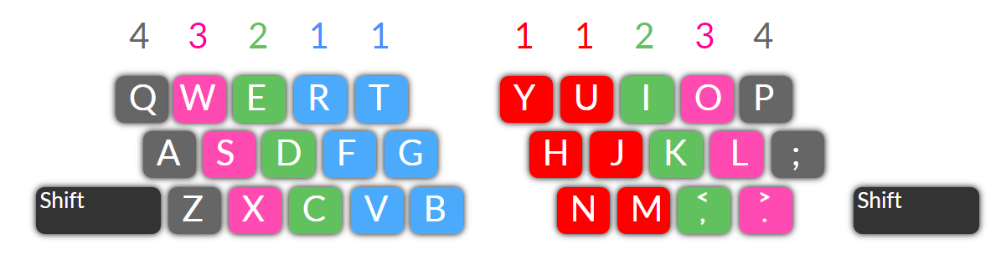Type **A** with the **Left** little finger and **P** with the **Right** little finger.

## faf far fat fatter far farmer faf far fat fatter far farmer frame fame famine fade

## fan ran tan jan land hand band fan ran tan jan land hand band sand banner

## pot port pit put pop pup puppy pot port pit put pop pup puppy poppy pappy

## purr top rope romp trap tramp trumpet purr top rope romp trap tramp trumpet

Some more practice typing the letter **G** and the letter combination **NG**

## fig rig tig pig got grip grab grasp green fig rig tig pig got grip grab grasp green

## ring ding dong song sang singer arrange ring ding dong song sang singer range

# Exercises

Type the letter **Q** with the Left little finger.

## quit quite quiet quill queen quilt quest quit quite quiet quill queen quilt ques

## quote quoted equate equation equal quack quaint quote quoted equate equation

## type Z with the Left hand little finger and X with the Left hand ring finger.

## zoo zulu zigzag fax tax text exit mix fix zoo zulu zigzag fax tax text exit mix fix

## six zoom boxes gizmo mixed maze raze lax flax size mixes zit sox zany lazy yax

# Try these sentence

## We took the children to see zebras and giraffes at the zoo last Friday. They had fun.

## Make sure you type the correct text in your document or it will not make sense.

## I hope the Learn Typing course has made your typing experience so much better.